

Develop Smart home System Using (ESP32)

ANAS MOHAMMED AMEEN
f2020108017@umt.edu.pk

Introduction

There’s a lot of noise at the moment about the Internet of Things (or IoT) and its impact on everything from the way we travel and do our shopping to the way manufacturers keep track of inventory.

What is the Internet of Things?

In a nutshell, the Internet of Things is the concept of connecting any device (so long as it has an on/off switch) to the Internet and to other connected devices. The IoT is a giant network of connected things and people – all of which collect and share data about the way they are used and about the environment around them.
The Internet of things (IoT) describes the network of physical objects—“things”—that are embedded with sensors, software, and other technologies for the purpose of connecting and exchanging data with other devices and systems over the Internet.

For that definition the IOT take many Scenarios to make the smart life

for human and one of this scenarios is to make the smart home and that’s what we will explain in details about the smart home and how to implement it.

The main component of the IOT

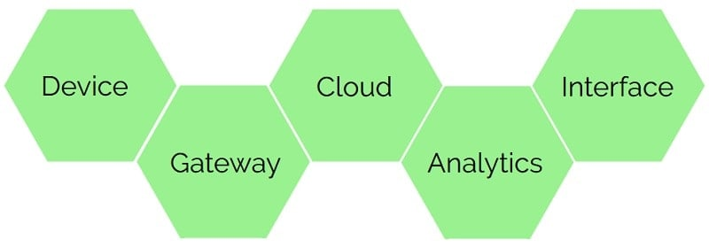

There are many topographies of how a sound IoT system should look. They all share the same idea – it all starts with the device or thing which generates and provides the data. Data from one or multiple devices are gathered, aggregated and sent to storage or cloud service. Probably one of the most critical elements of IoT is Analytic. Analytics tools incorporate all possible ways, including statistics, machine learning, big data technologies to make data understandable and use-able. This data can then be accessed through the user interface. User should have the ability not only to see the information but also alter it and even control the devices and actuators if needed.

Our Project

for our project we use the (ESP32) a low-powered, low-cost microcontroller (MCU) board, with both Wi-Fi and Bluetooth built in, and is based on a dual-core processor mechanism the ESP32 provide us an extra CPU core, faster Wi-Fi (compare to NodeMcu) which will be the way of communication to control.

And we will connected it with relay to give us the ability to programming the switch to control the open/close for any device that use high voltage

Also we use 2-bulb (220V) to control it via wifi as it’s showing in the pictures

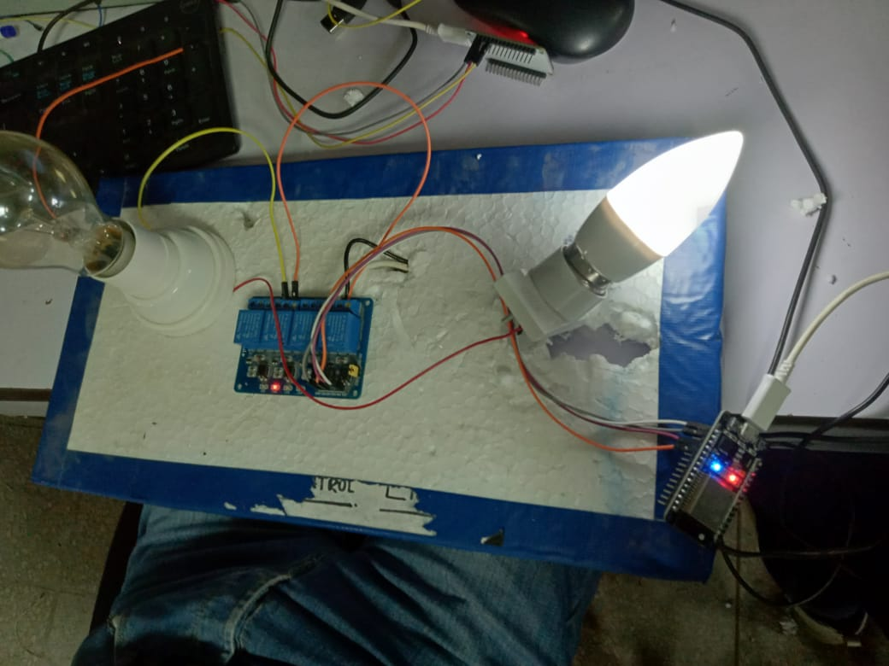 | 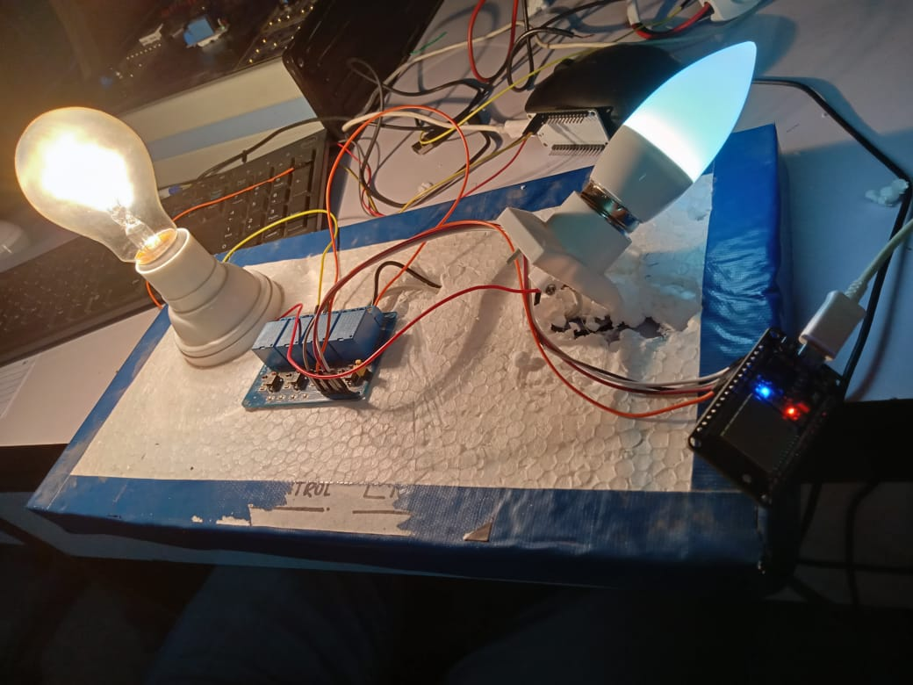
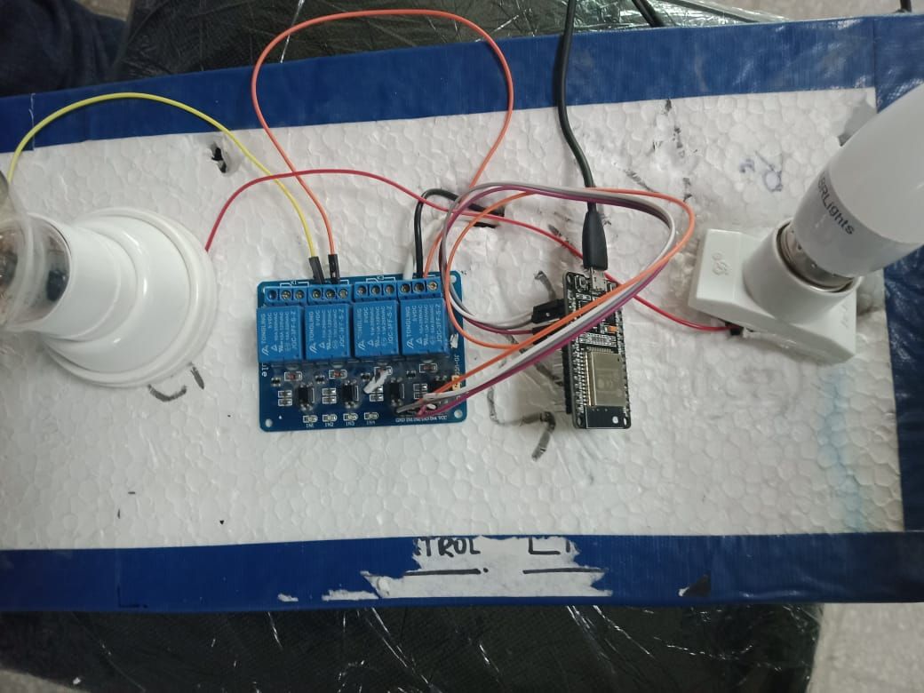 | 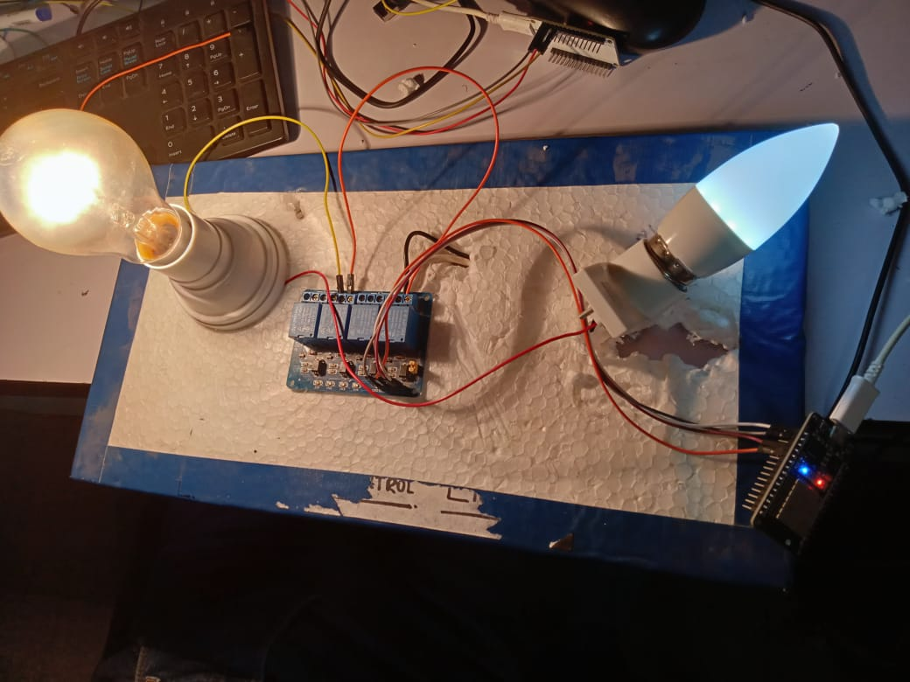

The Implement of the Project:-

ESP32 Connecting
first we will connect the jump wire to the following pins:-
one will connect to the 3v3.
One will connect to the GND.
One will connect to the D2(for connecting to the first bulb) .
One will connect to the D4(for connecting to the second bulb).
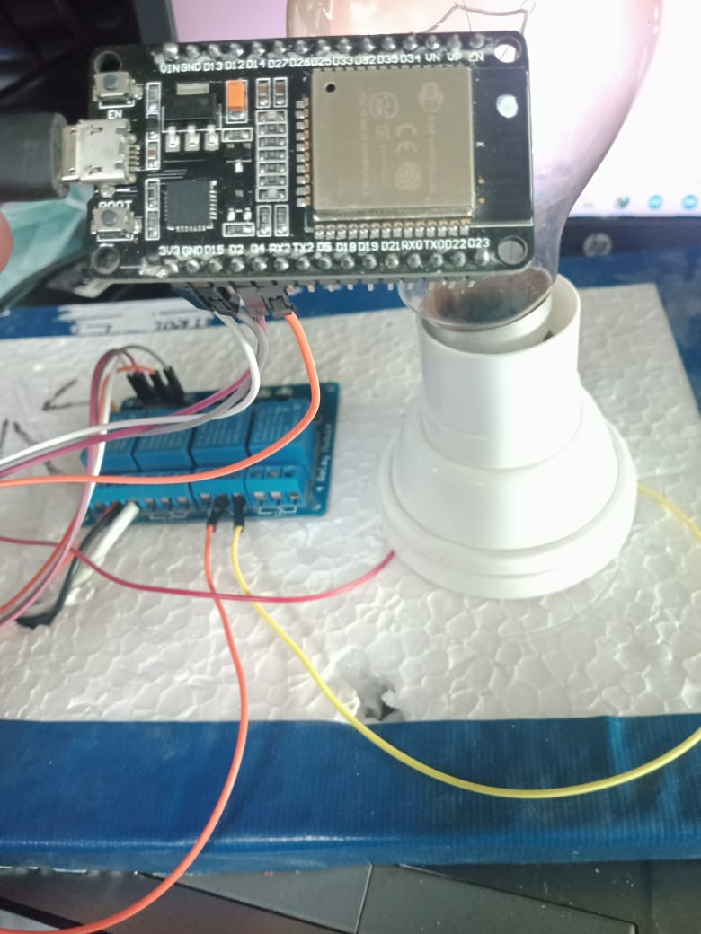

Relay Connecting
we will connect the jump wire into following pins:-
the wire of 3v3 in the Esp32 will connect into the VCC of the relays.
The wire of GND will connect into the GND of the relays.
The wire of D2 will connect into the IN4(use the 4th relay).
The wire of D4 will connect into the IN2(use the 2nd relay).
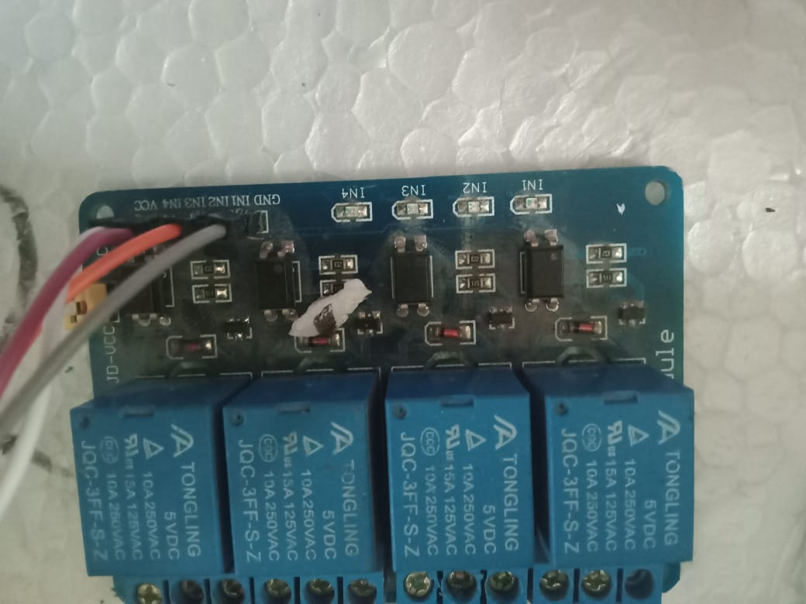

On the other side of the relays connection
in the 2nd and 4th we will connect the com of both of them to the direct 220V.
and for the 2nd relay in the NIC will connect to the first bulb.
For the 4th relay in the NIC will connect to the second bulb.
As showing on the following pictures

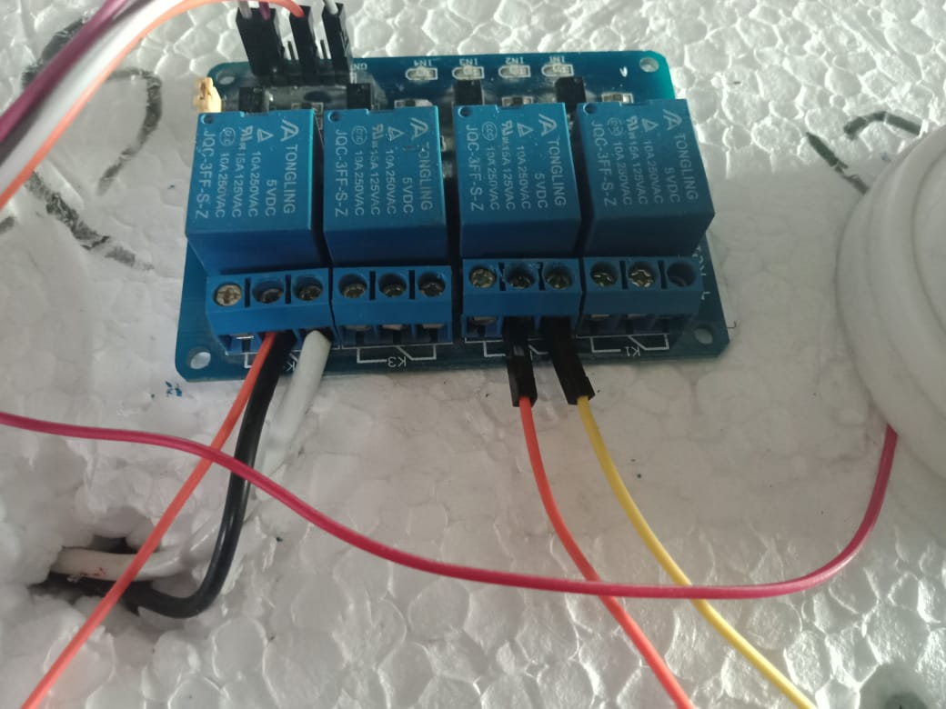

after that we will need the code to implement inside the ESP32.
(you can fined the code in git hub link(https://github.com/anas-dev-92/controlling-the-lights-via-wifi-.git)).

And also we need to install the blink app in the app Store and then make the account inside the app

after that we need to make button inside the app project and chose the pin that use inside the project( 2nd and 4th ).
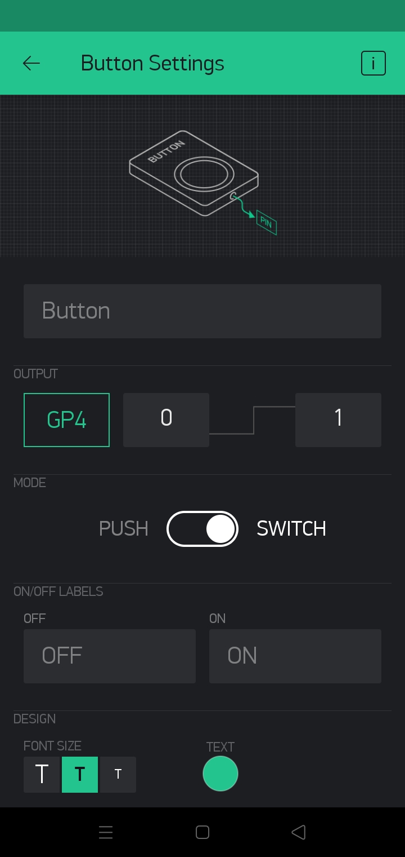 | 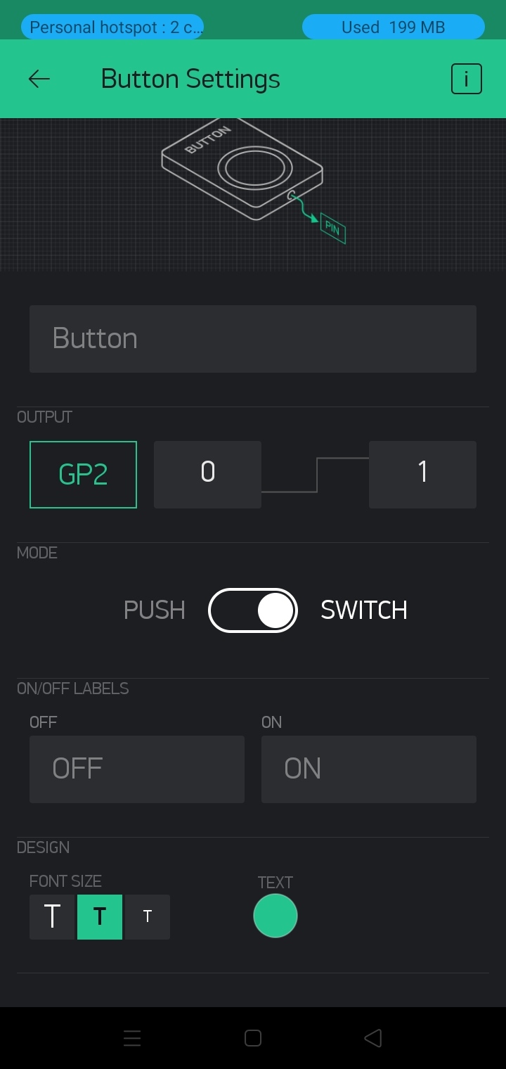

Conclusion:
in this simple project we implement the way of controlling the lights via wifi.

also we can improve the project by add more devices like(fan) to the relay and control it.

